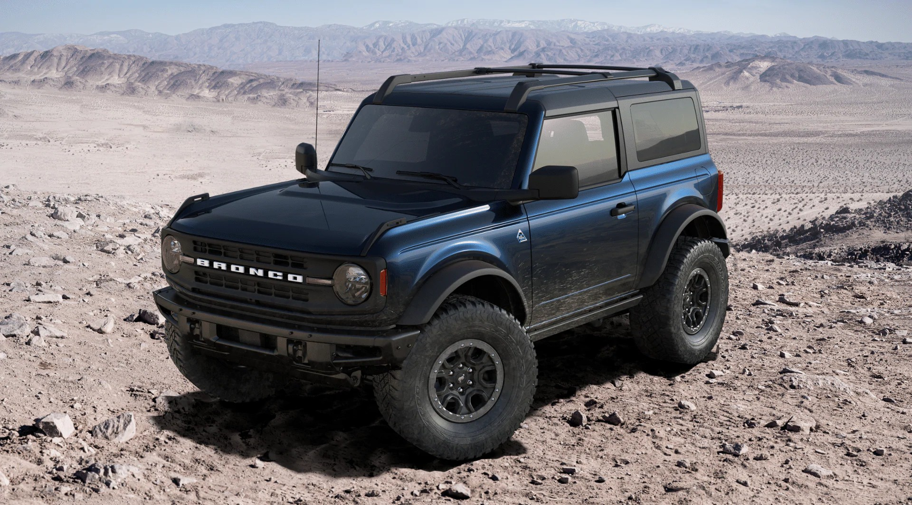

2021 Bronco
B L A C K D I A M O N D
S U M M A R Y

$47,185
i
E S T I M AT E D N E T P R I C E S5

$802
P E R M O N T H F O R 6 0 M O N T H F I N A N C E S6

$0
Top – Hard Top, Molded-in-Color (MIC)
$0
LT315/70R17 Mud-Terrain (M/T) Tires
$0
17" Black High Gloss-Painted Aluminum, Beadlock Capable Wheels
$0
Antimatter Blue
E X T E R I O R S4

Roof Rails with Crossbars – Black |  | $365
Front Bumper - Heavy-Duty Modular |  | $0
Upgraded Bash Plates |  | $0
Remote Start System |  | $0

I N T E R I O R S4

Black Onyx $0

Marine Grade Vinyl Seats With Dark Space Gray $0

Dual-Zone Electronic Automatic Temperature Control (DEATC) $0

Auxiliary Switches in Overhead Console with Front Map Lights $0

Storage Bag - Front Row Top Panels (for On-Vehicle Storage) $0

Power Outlet - Back Side of Center Floor Console $0

SYNC®4 with Enhanced Voice Recognition, LCD Capacitive Touchscreen $0 with Swipe Capability and Connected Navigation

SiriusXM® With 360L $0

SYNC®4 with Enhanced Voice Recognition $0

Connected Navigation $0
P O W E R T R A I N S S4

2.7L EcoBoost® Engine $1,895

10-Speed SelectShift® Automatic Transmission $0

Advanced 4x4 with Automatic On-Demand Engagement $0

Rear Locking Differential $0

4.7 Locking Rear Axle Final Drive Ratio $0

PA C K A G E S S4

Mid Package | $1,495
Sasquatch™ Package | $4,495
Towing Capability | $595
Ford Co-Pilot360™ Package | $0

P R I C I N G S U M M A R Y

BASE MSRP S1 | $36,050
OPTIONS S4 & ACCESSORIES S8 | + $9,640
DESTINATION CHARGES S17 | + $1,495
TOTAL MSRP S16 | = $47,185
ESTIMATED NET PRICE S5 | = $47,185
MONTHLY PAYMENT S6 | $802

