Lower Arm
Special Tool(s) / General Equipment
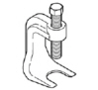 | 204-592  Separator, Lower Arm Ball Joint  TKIT-2006C-FFMFLM  TKIT-2006C-LM  TKIT-2006C-ROW
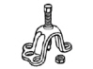 | 205-D070 (D93P-1175-B)  Remover, Front Wheel Hub
Vehicle/Axle Stands
Removal
NOTICE: Suspension fasteners are critical parts that affect the performance of vital components and systems. Failure of these fasteners may result in major service expense. Use the same or equivalent parts if replacement is necessary. Do not use a replacement part of lesser quality or substitute design. Tighten fasteners as specified.
- Measure and record the distance from the center of the hub to the lip of the fender with the vehicle in a level, static ground position (curb height).
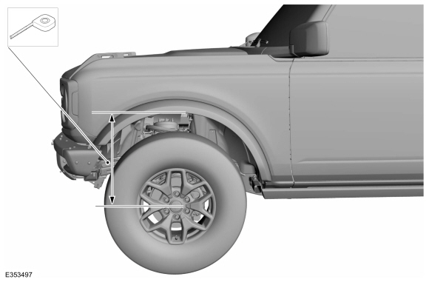
- Remove the wheel and tire.
Refer to: Wheel and Tire (204-04A Wheels and Tires, Removal and Installation).
- NOTE: This step requires the aid of another technician.
NOTE: Apply the brake to prevent the halfshaft from rotating while loosening the wheel hub nut.
Remove and discard the wheel hub nut.
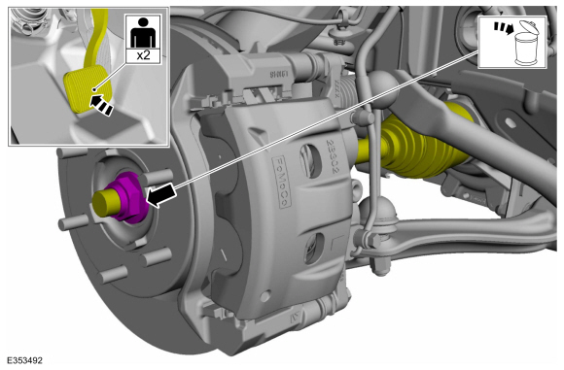
- Using the special tool, press the halfshaft from the front wheel bearing and hub and support the halfshaft using mechanic's wire.
Use Special Service Tool: 205-D070 (D93P-1175-B) Remover, Front Wheel Hub.
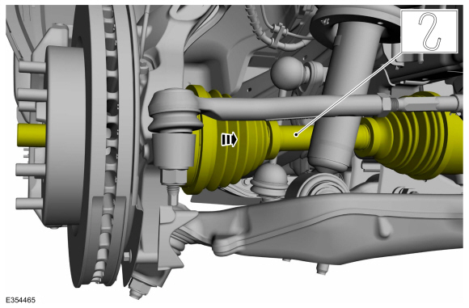
- Remove and discard the shock absorber assembly lower nuts.
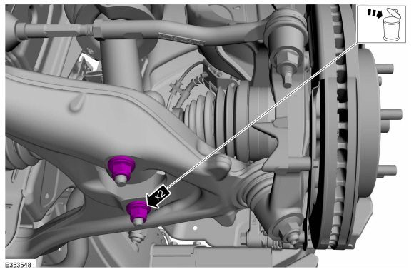
- NOTE: The stabilizer bar links are designed with low friction ball joints that have a low breakaway torque.
NOTE: Use the hex-holding feature to prevent the stud from turning while removing the nuts.
Remove and discard the stabilizer bar link lower nut.
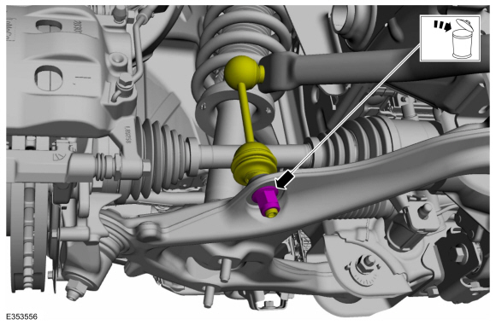
- If equipped.
Remove and discard the bolts and remove the stabilizer bar undershield.
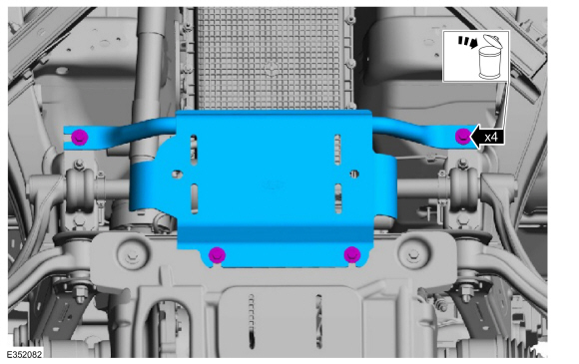
- NOTE: Note the position of each component before removal.
  - Remove and discard the front stabilizer bar assembly nut and bolt.
  - Position aside the front stabilizer bar assembly and support the front stabilizer bar assembly using mechanic's wire.
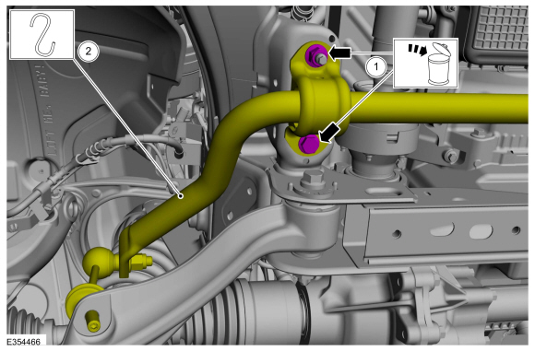
- NOTICE: Never allow the knuckle to hang from the upper and lower control arms or damage to the ball joints can occur.
NOTE: Take care not to damage coating on suspension components.
Support the wheel knuckle assembly using mechanic's wire.
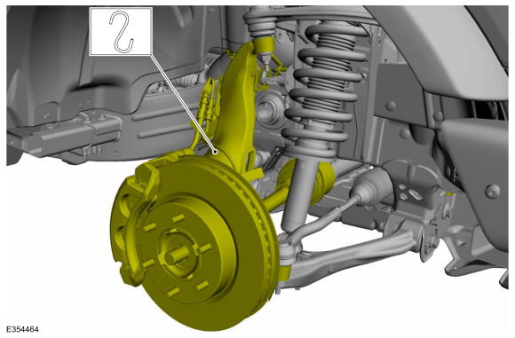
- NOTE: Use the hex-holding feature to prevent the stud from turning while removing the nut.
Remove and discard the lower ball joint nut.
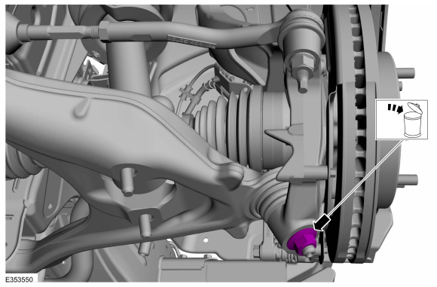
- NOTICE: Do not use a prying device or separator fork between the ball joint and the wheel knuckle. Damage to the ball joint or ball joint seal may result.
NOTICE: Use care when releasing the lower arm and wheel knuckle into the resting position or damage to the ball joint seal may occur.
NOTICE: Do not damage the ball joint boot while installing the special tool.
Separate the lower ball joint from the wheel knuckle.
Use Special Service Tool: 204-592 Separator, Lower Arm Ball Joint.
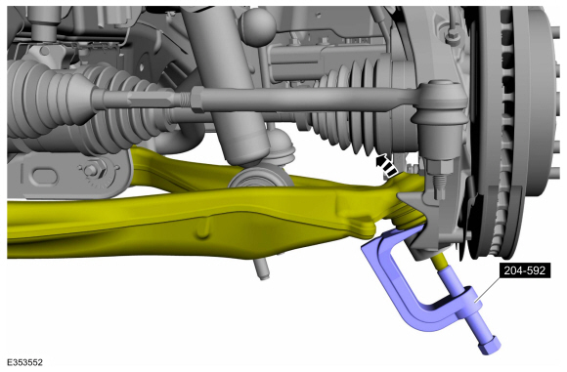
- Remove and discard the lower arm bolts, nuts and washers and remove the lower arm.
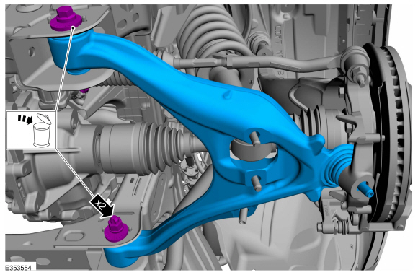
Installation
NOTICE: Tighten the suspension bushing fasteners with the suspension raised by a jack to curb height or with the weight of the vehicle resting on the wheels and tires. Otherwise, damage to the bushings may occur.
- NOTE: Only tighten the nuts and bolts finger tight at this stage.
Install the lower arm and install the new lower arm bolts, nuts and washers.
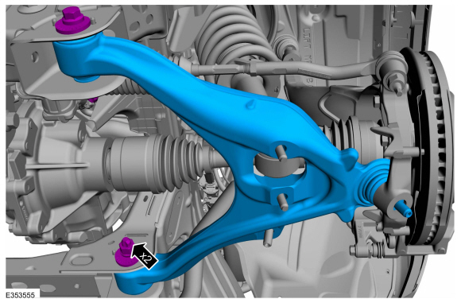
- NOTE: Make sure that the component is installed to the position noted before removal.
  - Position the front stabilizer bar assembly and install the new stabilizer bar bracket nut and bolt.
Torque: 66 lb.ft (90 Nm)
  - NOTE: The stabilizer bar links are designed with low friction ball joints that have a low breakaway torque.
NOTE: Use the hex-holding feature to prevent the stud from turning while removing the nuts.
Position the stabilizer bar link and install the new stabilizer bar link lower nut.
Torque: 122 lb.ft (165 Nm)
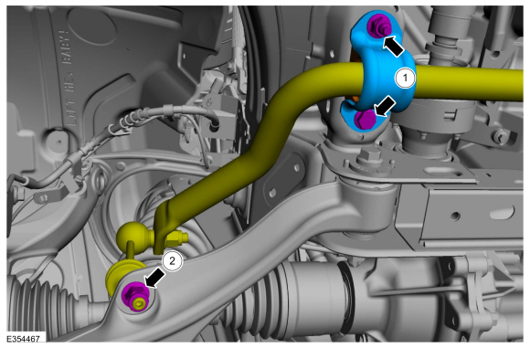
- If removed.
Install the stabilizer bar undershield and install the new stabilizer bar undershield bolts.
Torque: 26 lb.ft (35 Nm)
- Attach the lower ball joint to the wheel knuckle.
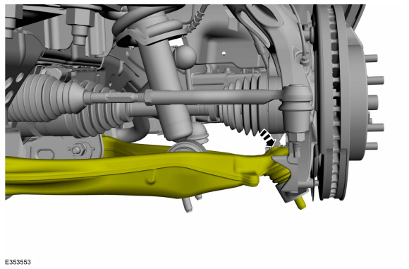
- NOTE: Use the hex-holding feature to prevent the stud from turning while installing the nut.
Install the new lower ball joint nut.
Torque: 85 lb.ft (115 Nm)
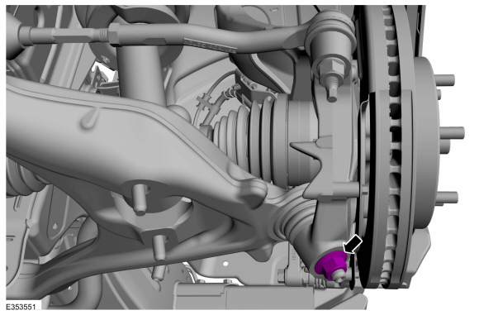
- With old hub nut pull the halfshaft into hub and discard the old wheel hub nut.
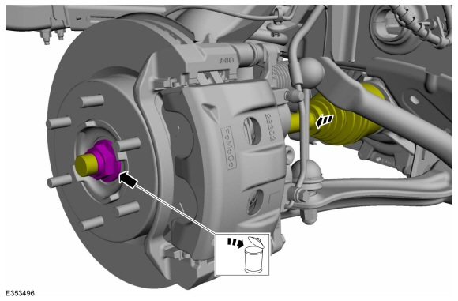
- NOTICE: Install and tighten the new wheel hub nut to specification in a continuous rotation. Always install a new wheel hub nut after loosening or when not tightened to specification in a continuous rotation or damage to the components may occur.
NOTE: This step requires the aid of another technician.
NOTE: Apply the brake to keep the halfshaft from rotating.
While an assistant applies the brake, install the new halfshaft nut.
Torque: 221 lb.ft (300 Nm)
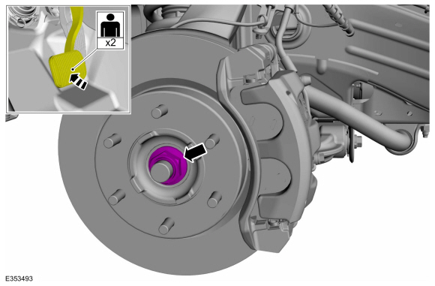
- Install the new shock absorber assembly lower nuts.
Torque: 66 lb.ft (90 Nm)
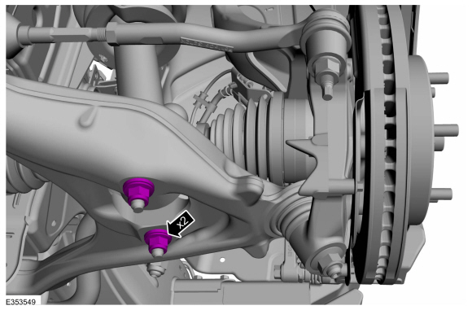
- Use a suitable jack to raise the suspension until the distance between the center of the hub and the lip of the fender is equal to the measurement taken during removal (curb height).
Use the General Equipment: Vehicle/Axle Stands
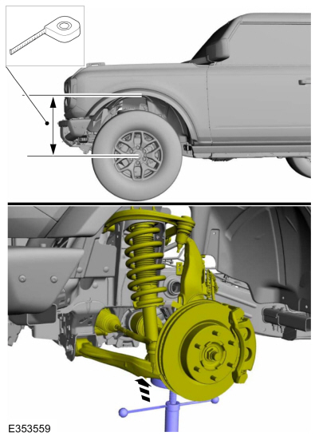
- NOTICE: Tighten the suspension bushing fasteners with the suspension raised by a jack to curb height or with the weight of the vehicle resting on the wheels and tires. Otherwise, damage to the bushings may occur.
Tighten the new lower arm bolts and nuts.
Torque: 210 lb.ft (285 Nm)
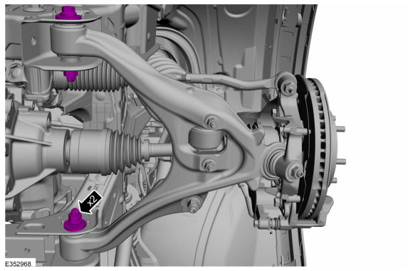
- Install the wheel and tire.
Refer to: Wheel and Tire (204-04A Wheels and Tires, Removal and Installation).
- Check and if necessary adjust front camber and caster.
Refer to: Front Camber and Caster Adjustment (204-00 Suspension System - General Information, General Procedures).
- Check and if necessary adjust front toe.
Refer to: Front Toe Adjustment (204-00 Suspension System - General Information, General Procedures).
© Copyright 2022, Ford Motor Company.

Lower Arm
Special Tool(s) / General Equipment
204-592
Separator, Lower Arm Ball Joint
TKIT-2006C-FFMFLM
TKIT-2006C-LM
TKIT-2006C-ROW
205-D070 (D93P-1175-B)
Remover, Front Wheel Hub
Vehicle/Axle Stands
Removal
NOTICE: Suspension fasteners are critical parts that affect the performance of vital components and systems. Failure of these fasteners may result in major service expense. Use the same or equivalent parts if replacement is necessary. Do not use a replacement part of lesser quality or substitute design. Tighten fasteners as specified.
- Measure and record the distance from the center of the hub to the lip of the fender with the vehicle in a level, static ground position (curb height).
- Remove the wheel and tire.
Refer to: Wheel and Tire (204-04A Wheels and Tires, Removal and Installation).
- NOTE: This step requires the aid of another technician.
NOTE: Apply the brake to prevent the halfshaft from rotating while loosening the wheel hub nut.
Remove and discard the wheel hub nut.
- Using the special tool, press the halfshaft from the front wheel bearing and hub and support the halfshaft using mechanic's wire.
Use Special Service Tool: 205-D070 (D93P-1175-B) Remover, Front Wheel Hub.
- Remove and discard the shock absorber assembly lower nuts.
- NOTE: The stabilizer bar links are designed with low friction ball joints that have a low breakaway torque.
NOTE: Use the hex-holding feature to prevent the stud from turning while removing the nuts.
Remove and discard the stabilizer bar link lower nut.
- If equipped.
Remove and discard the bolts and remove the stabilizer bar undershield.
- NOTE: Note the position of each component before removal.
  - Remove and discard the front stabilizer bar assembly nut and bolt.
  - Position aside the front stabilizer bar assembly and support the front stabilizer bar assembly using mechanic's wire.
- NOTICE: Never allow the knuckle to hang from the upper and lower control arms or damage to the ball joints can occur.
NOTE: Take care not to damage coating on suspension components.
Support the wheel knuckle assembly using mechanic's wire.
- NOTE: Use the hex-holding feature to prevent the stud from turning while removing the nut.
Remove and discard the lower ball joint nut.
- NOTICE: Do not use a prying device or separator fork between the ball joint and the wheel knuckle. Damage to the ball joint or ball joint seal may result.
NOTICE: Use care when releasing the lower arm and wheel knuckle into the resting position or damage to the ball joint seal may occur.
NOTICE: Do not damage the ball joint boot while installing the special tool.
Separate the lower ball joint from the wheel knuckle.
Use Special Service Tool: 204-592 Separator, Lower Arm Ball Joint.
- Remove and discard the lower arm bolts, nuts and washers and remove the lower arm.
Installation
NOTICE: Tighten the suspension bushing fasteners with the suspension raised by a jack to curb height or with the weight of the vehicle resting on the wheels and tires. Otherwise, damage to the bushings may occur.
- NOTE: Only tighten the nuts and bolts finger tight at this stage.
Install the lower arm and install the new lower arm bolts, nuts and washers.
- NOTE: Make sure that the component is installed to the position noted before removal.
  - Position the front stabilizer bar assembly and install the new stabilizer bar bracket nut and bolt.
Torque: 66 lb.ft (90 Nm)
  - NOTE: The stabilizer bar links are designed with low friction ball joints that have a low breakaway torque.
NOTE: Use the hex-holding feature to prevent the stud from turning while removing the nuts.
Position the stabilizer bar link and install the new stabilizer bar link lower nut.
Torque: 122 lb.ft (165 Nm)
- If removed.
Install the stabilizer bar undershield and install the new stabilizer bar undershield bolts.
Torque: 26 lb.ft (35 Nm)
- Attach the lower ball joint to the wheel knuckle.
- NOTE: Use the hex-holding feature to prevent the stud from turning while installing the nut.
Install the new lower ball joint nut.
Torque: 85 lb.ft (115 Nm)
- With old hub nut pull the halfshaft into hub and discard the old wheel hub nut.
- NOTICE: Install and tighten the new wheel hub nut to specification in a continuous rotation. Always install a new wheel hub nut after loosening or when not tightened to specification in a continuous rotation or damage to the components may occur.
NOTE: This step requires the aid of another technician.
NOTE: Apply the brake to keep the halfshaft from rotating.
While an assistant applies the brake, install the new halfshaft nut.
Torque: 221 lb.ft (300 Nm)
- Install the new shock absorber assembly lower nuts.
Torque: 66 lb.ft (90 Nm)
- Use a suitable jack to raise the suspension until the distance between the center of the hub and the lip of the fender is equal to the measurement taken during removal (curb height).
Use the General Equipment: Vehicle/Axle Stands
- NOTICE: Tighten the suspension bushing fasteners with the suspension raised by a jack to curb height or with the weight of the vehicle resting on the wheels and tires. Otherwise, damage to the bushings may occur.
Tighten the new lower arm bolts and nuts.
Torque: 210 lb.ft (285 Nm)
- Install the wheel and tire.
Refer to: Wheel and Tire (204-04A Wheels and Tires, Removal and Installation).
- Check and if necessary adjust front camber and caster.
Refer to: Front Camber and Caster Adjustment (204-00 Suspension System - General Information, General Procedures).
- Check and if necessary adjust front toe.
Refer to: Front Toe Adjustment (204-00 Suspension System - General Information, General Procedures).
© Copyright 2022, Ford Motor Company.

